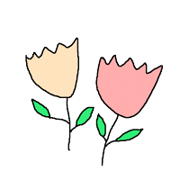
Mrs. Myers’ April Specials/Behavior Calendar
Monday | Tuesday | Wednesday | Thursday | Friday
4  Music | 5  Spanish | 6  Art | 7  Computer | 8  STEM
11  PE | 12  Music | 13  Spanish | 14  Art | 15  No Specials
18  Computer | 19  STEM | 20  PE | 21  Music | 22  Spanish
25  Art | 26  Computer | 27  STEM | 28  PE | 29  Music

Behavior Colors:
Green - Ready to Learn (All students begin their day on green)
Blue - Warning
Yellow - Think About It – needed several warnings
Red - Parent Contact
Purple - Outstanding (treasure box/positive note home)

Comments ______________________________________________________

______________________________________________________________

______________________________________________________________

______________________________________________________________

